**Lesson 07 Demo 04**

**Automating Test Case Generation Using testRigor**

**Objective:** To automate test case generation and execution process using testRigor for an

e-commerce website for ensuring the functionality and user experience meet specified requirements

**Tools required:** testRigor

**Prerequisites:** Basic knowledge and understanding of test cases

Steps to be followed:

1. Generate and execute the test cases using testRigor

|  |
| --- |
| **Note:** Please note that all the generative AI tools used in this exercise can produce varied outputs even when presented with similar prompts. Thus, you may get different outputs for the same prompt. |

**Step 1:** **Generate and execute the test cases using testRigor**

* 1. Navigate to **https://testrigor.com/**

1. Click on the **Login** button, as shown in the screenshot below:  
     
   A screenshot of a computer

   Description automatically generated  
   1. Add the login credentials in the following text area:  
        
      A screenshot of a login form

      Description automatically generated

|  |
| --- |
| **Note**: Sign up if you do not have an account |

* 1. Enter the desired test suite name, as shown in the screenshot below:  
       
     A screenshot of a computer

     Description automatically generated
  2. Select the desired type of testing, as shown in the screenshot below:  
       
     A screenshot of a computer

     Description automatically generated
  3. Add the following URL, as shown in the screenshot below:  
     **https://www.amazon.in**

|  |
| --- |
| **Note**: You may add any desired website URL. |

* 1. Add the credentials for the login, if any  
       
     A screenshot of a computer

     Description automatically generated
  2. Select the desired operating system, as shown in the screenshot below:  
       
     A screenshot of a computer

     Description automatically generated
  3. Select the desired browser, as shown in the screenshot below:  
       
     A screenshot of a computer

     Description automatically generated
  4. Select and specify the desired number of test cases, as shown in the screenshot below:  
       
     A screenshot of a computer

     Description automatically generated
  5. Add a detailed description of the user interaction steps for purchasing an item in the **App Description** section, as shown in the screenshot below. You may use the following description for reference:  
     **Click on the Search input area**

**Search for Apple iPhone 15 (128 GB) - Black**

**Validate if the text "Apple iPhone 15 (128 GB) - Black" in present**

**Click on Add to cart**

**Click on Go to Cart**

**Validate if the page contains the text "Shopping Cart"**

**Click on Proceed to buy**  
  
* 1. Click on the **Create Test Suite** button, as shown in the screenshot below:  
       
     A screenshot of a computer

     Description automatically generated
  2. Click on the **Generate the Tests** button  
       
     A screenshot of a computer

     Description automatically generated  
       
       
       
       
       
       
       
       
       
       
       
     You will see the following interface:  
       
     A screenshot of a computer

     Description automatically generated

|  |
| --- |
| **Note**: The test cases may not give the expected output as you have selected five different test cases for each functionality. |

* 1. Click on the down-arrow icon of the passed test case to see the screenshots and output, as shown in the screenshot below:  
       
     A screenshot of a computer

     Description automatically generated

* 1. Scroll up and click on **Cancel testing,** as shown in the screenshot below:  
       
     A screenshot of a computer

     Description automatically generated
  2. Click on **Cancel task,** as shown in the screenshot below:  
       
     A screenshot of a computer

     Description automatically generated
  3. Click on **Add Custom Test Case** to create a new test case  
       
     A screenshot of a computer

     Description automatically generated
  4. Add a brief description, as shown in the screenshot below:  
     **Find Apple iPhone 15 (128 GB) – Black, add it to the cart and proceed to the checkout**  
       
     A screenshot of a computer

     Description automatically generated

|  |
| --- |
| **Note**: You may either mention each step as earlier or click on **Generate actual test using AI**. Initially, try adding custom steps and later utilize AI for generating tests, as shown in the next steps. |

* 1. Add the custom steps, as shown in the screenshot below. You may use the following description for reference:   
     **Click on the search input.**

**Type "Apple iPhone 15 (128 GB) - Black" and click on the search icon.**

**Verify that text "Apple iPhone 15 (128 GB) - Black" is present.**

**Click on "Add to Cart".**

**Click on "Go to Cart".**

**Check if the page contains "Shopping Cart".**

**Click on "Proceed to Buy".**

* 1. Click on the **Add and Run** button  
       
     A screenshot of a computer

     Description automatically generated
  2. Select **Create AI-based rule** under the **Actions to be done** section for all the steps, as shown in the screenshot below:  
       
     A screenshot of a computer

     Description automatically generated
  3. Click on the **Update and Retest** button  
       
     A screenshot of a computer

     Description automatically generated  
       
       
       
       
       
       
     You will see the following interface:  
       
     A screenshot of a computer

     Description automatically generated  
       
     The test case execution is in progress, as shown in the screenshot below:  
       
     A screenshot of a computer

     Description automatically generated
  4. Click on the down arrow icon, as shown in the screenshot below:  
       
     A screenshot of a computer

     Description automatically generated  
       
     You will see the screenshots generated during the test, as shown below:  
       
     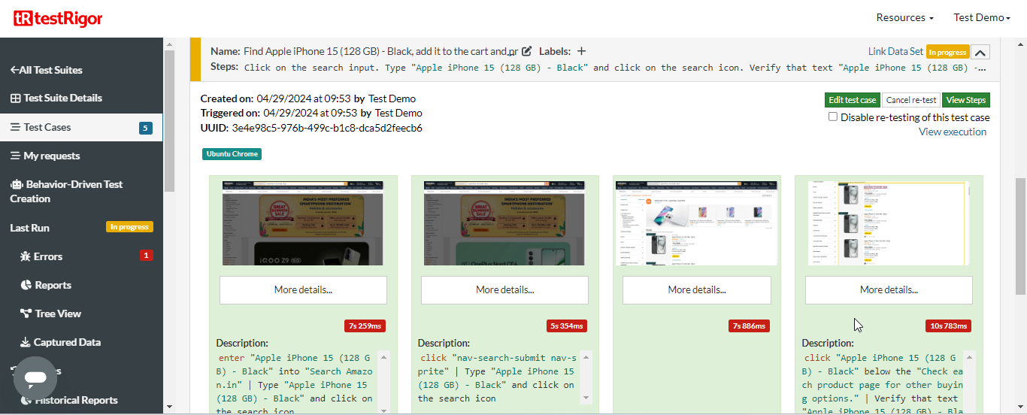
  5. Click and view the image, as shown in the screenshots below:  
       
     A screenshot of a computer

     Description automatically generated  
       
     A screenshot of a computer

     Description automatically generated
  6. Scroll up and click on **Add Customer Test Case**  
       
     A screenshot of a computer

     Description automatically generated
  7. Add a brief description and click on the **Generate actual test using AI** button, as shown in the screenshot below:  
     **Find Apple iPhone 15 (128 GB) – Black, add it to the cart and proceed to the checkout**  
       
     A screenshot of a computer

     Description automatically generated  
       
     A screenshot of a computer

     Description automatically generated  
       
     A screenshot of a computer

     Description automatically generated

|  |
| --- |
| **Note**: If a test case is fails, make the necessary changes and re-test them until you get the desired outcome. |

By following these steps, you have successfully automated the test case generation and execution process using testRigor to ensure the functionality and user experience of an e-commerce website meet specified requirements.